Neeraj Appari T073

Wireless Sensor Networks and Mobile Communication Practical 8

Aim: Create MAC protocol simulation implementation for wireless sensor Network.

Steps-

1)Take 1 Router, 3 Laptops, 2 Smartphones and 1 Tablet.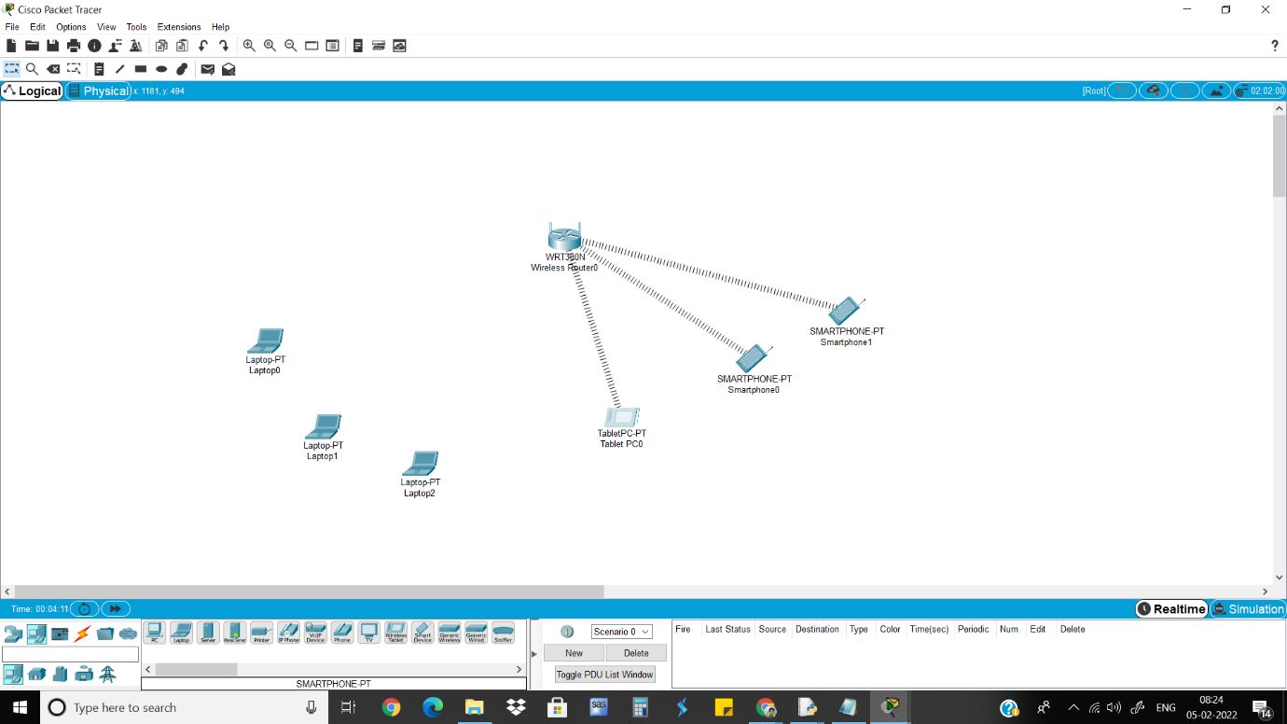

2)Adding the wireless port to each laptop so they connect to the router.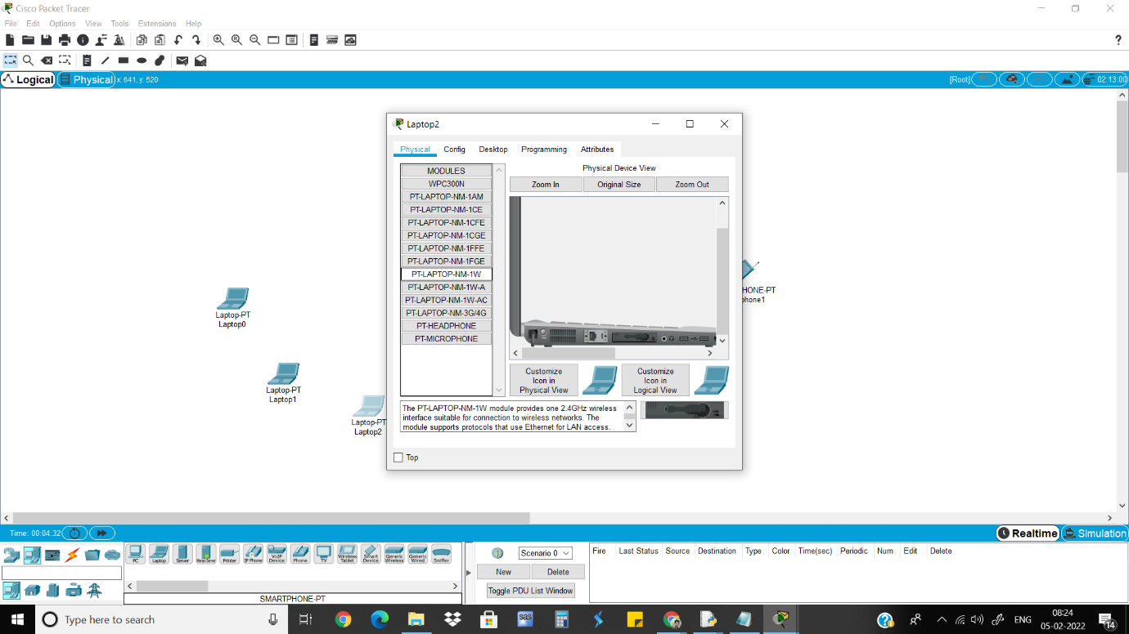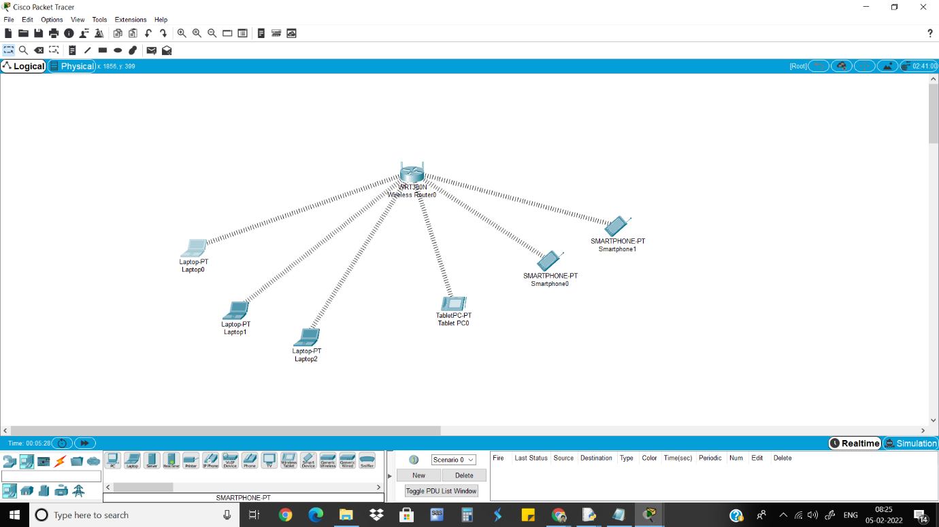

3)Copy the MAC address of each device.

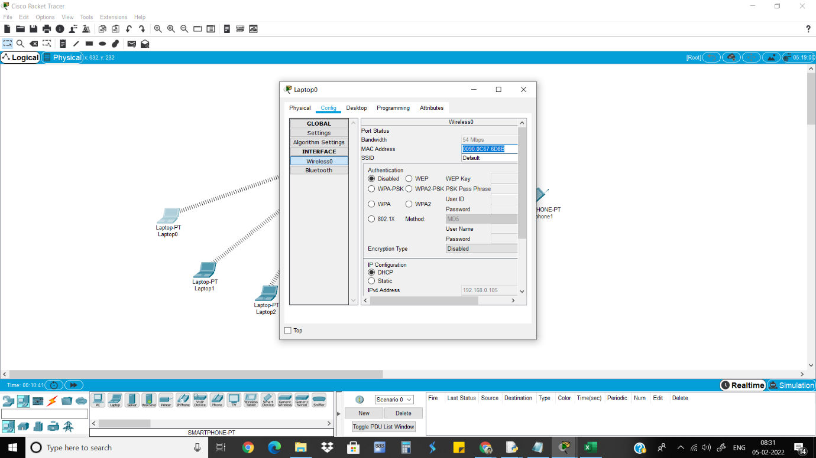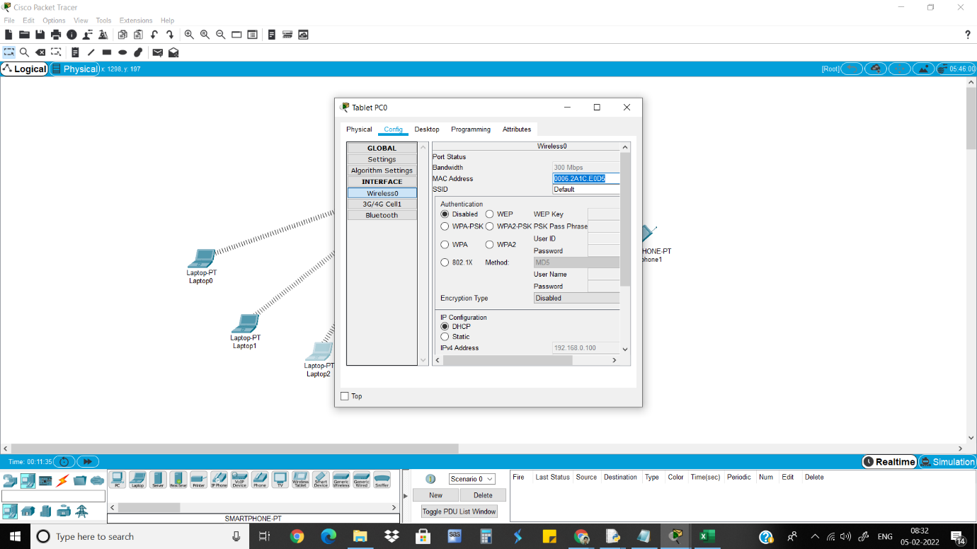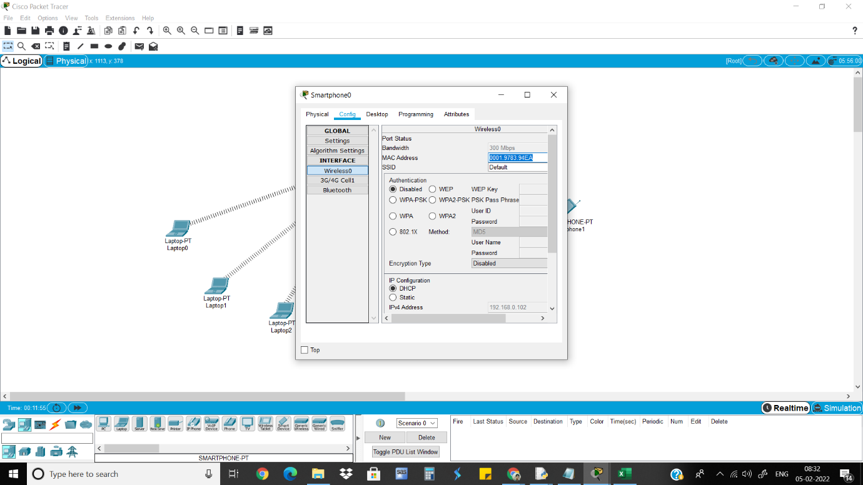

4)Convert MAC address.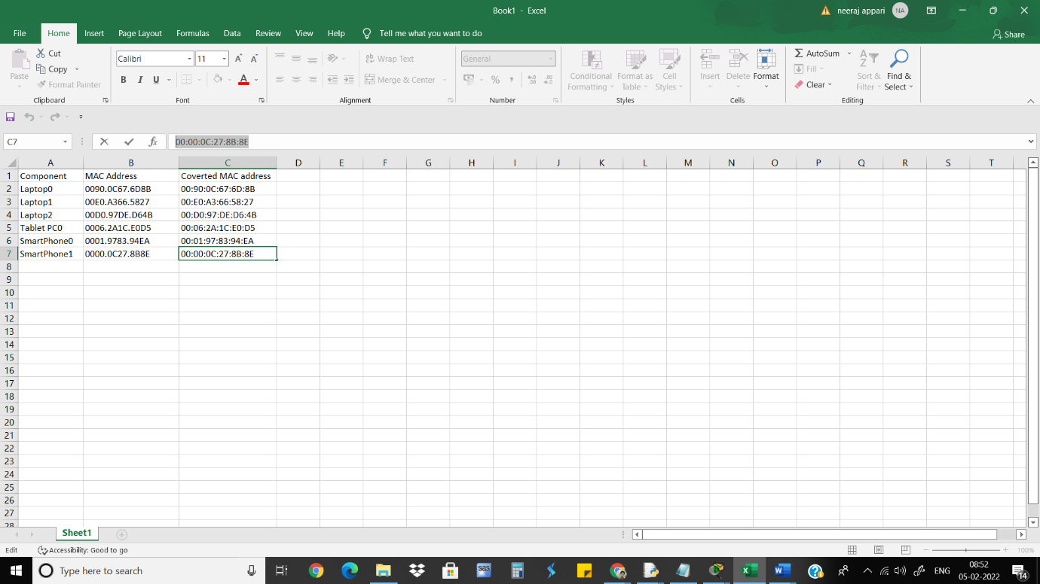

5)Go to Router>GUI>Wireless>Wireless MAC Filter and give MAC address that needs to be prevented connecting.

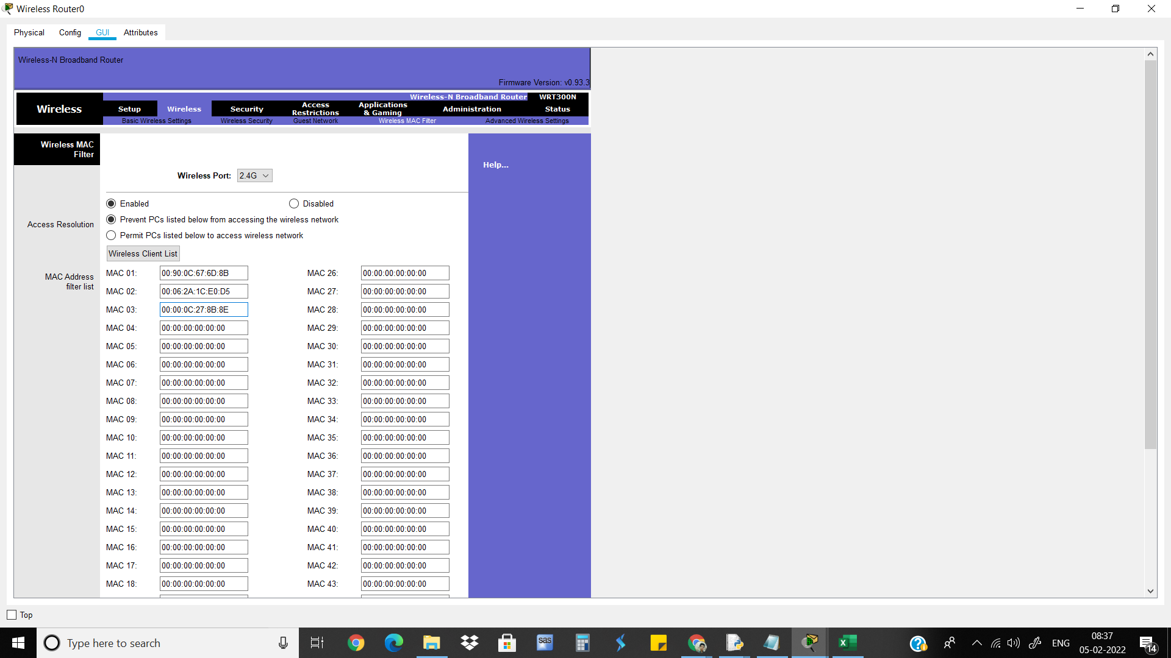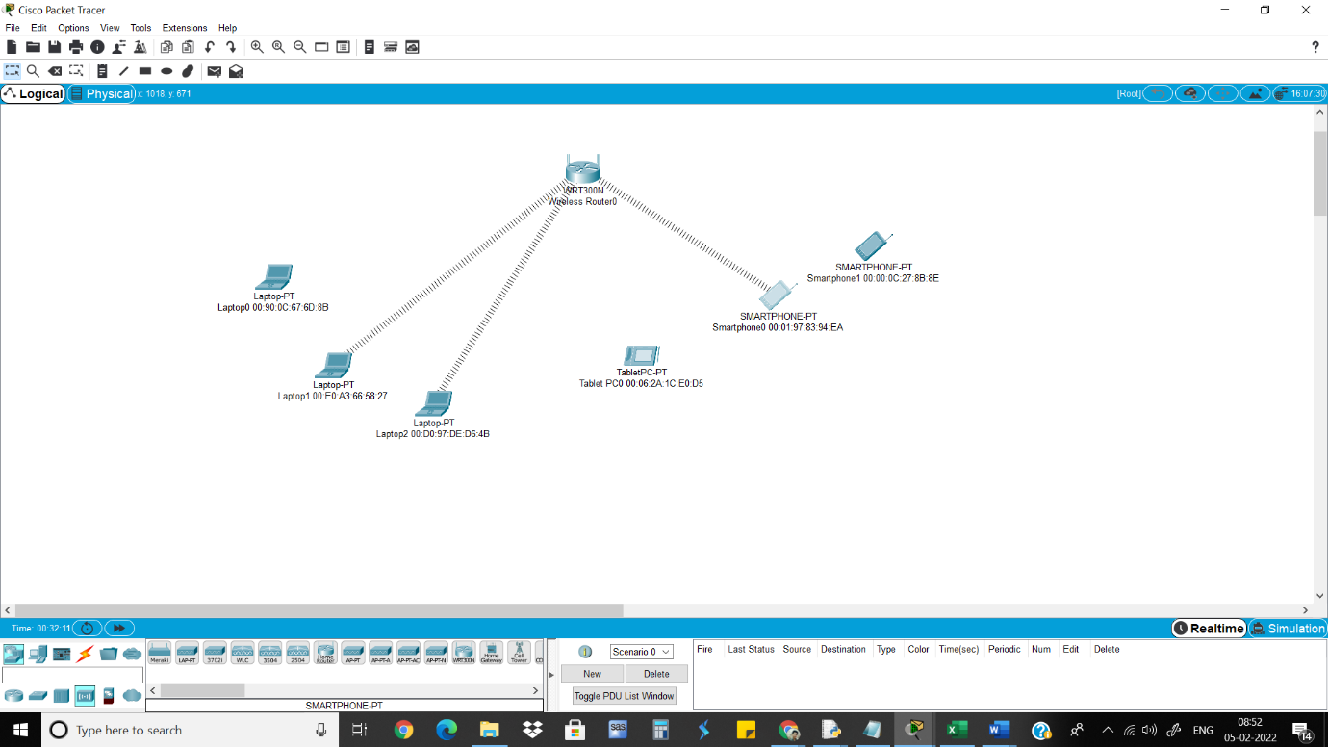

6)Then Give MAC address to permit the devices that needs to be connected